**12. Centrifuge Balance Checker**

**Condition:**

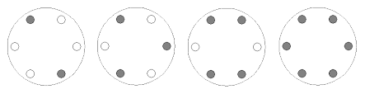A centrifuge is a laboratory device used to separate liquids based on their density. The separation is achieved by centrifugal force, by spinning test tubes at high speeds. You need to create a program that takes two numbers as arguments, **` n `** and **` k `** , and returns **true** if the configuration is in balance, and **false** if it is not. The balance check is performed based on these parameters.

**Input:**

* **` n `** : An integer representing the number of holes in the centrifuge.
* **` k `** : An integer representing the number of sample tubes.

**Output:**

* **` true `** or **` false `** , depending on whether the configuration is in balance or not.

**Examples:**

|  |  |
| --- | --- |
| **Input** | **Output** |
| 6, 4 | true |
| 2, 1 | false |